BFU: The Industrial Revolution
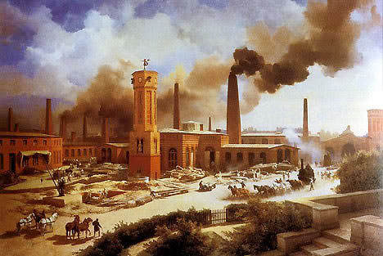

Misconceptions:

The French Revolution is the biggest revolution, ever. No wait, it was the American Revolution.

The Industrial Revolution is the biggest change in human history, ever. Ever! Life is pretty much the same for five thousand years.
For most of history, if you are born, you are a farmer.

Then comes the Industrial Revolution in the 1800s. Slowly, the world changes. England changes first. Then, Western Europe and the USA. Then, Eastern Europe, Russia, Argentina, Mexico, South Africa, India, China, on and on…

After a country industrializes, the majority of people aren’t farmers anymore. They are workers, businessmen, teachers, restaurant owners, etc.

Complete
1. Why is the Industrial Revolution important? (What is the big change?) is the biggest change in human history, ever.

2. Where does the Industrial Revolution start? In England

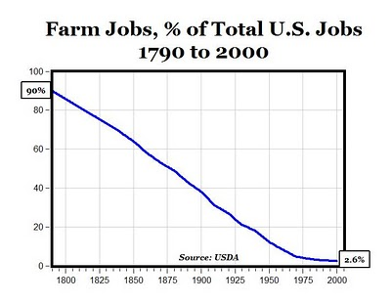
Here are some graphics:
This shows that in 1800, almost all Americans had a farm job.

America industrializes and now in 2000, only 2.6 percent have a farm job.
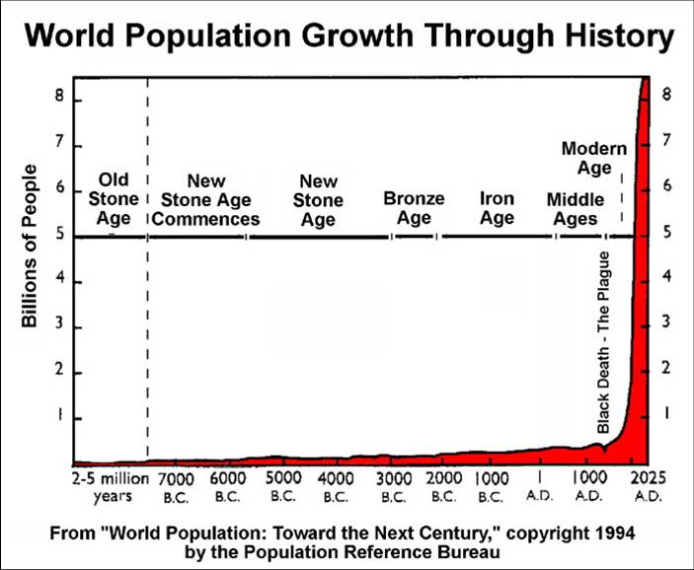
This shows that the world population is basically the same until the Industrial Revolution. But with urbanization, new technologies and medicines, and the new industrial economy, the growth explodes.

Rewrite
1. The graph shows the growth of the World Population.
2. The populations grows faster after the Industrial Revolution.
The Industrial Revolution is the change from an agricultural society to an industrial society. In an agricultural society, most people work in agriculture and they make most things they need to survive. They generally work for food, not wages.

Rewrite
1. The Industrial Revolution is the beginning of Industrial or modern society.
2. After the Industrial Revolution, people generally work for agriculture.
In an industrial society, factories produce everything people need to survive in great quantities. People mostly live in cities and work for wages, with which they buy what they need.
Agricultural societies are unable to support large populations whereas industrial societies can support huge populations due to better food, medicine, and division of labor.

Rewrite
1. Agricultural societies can’t support huge populations.
2. People can work in factories and other jobs because they don’t have to make their own food.
Technological advances happen rapidly in Industrial societies; we have only been industrialized for over 200 years and we’ve seen many changes from cars to phones to the internet. Agricultural society makes up most of human history and has seen very little technological advance.
Industrial society has created huge riches and opened up society. Businessmen from common families have become the most powerful people in the world; still, industrialization has created a huge divide between rich and poor. All in all, we still don’t fully understand the changes that industrialization has brought us.

Rewrite
1. Technological advances happen after the Industrial societies.
2. The Industrial Revolution makes it easy to change your position in life.
3. The divide between the rich and poor increase during the Industrial Revolution.

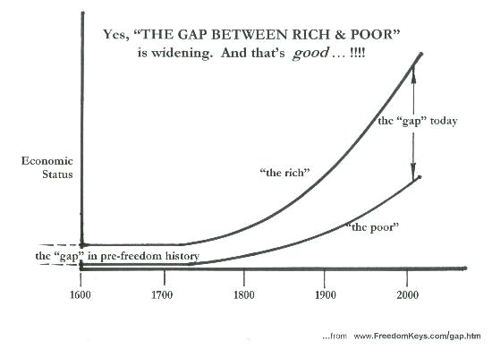
Here are the positives from industrialization:

New technologies and medicines lead to huge population growth. Meanwhile, new jobs like management lead to bigger middle class; not everyone is just rich or just poor anymore.

Summarize
Most of the things are benefit for the whole population and its really good to have people in the middle class because in this way no one will feel more than others.
Urbanization leads to new ideas and new freedoms because everyone is together in the cities. Some of these ideas include the right to vote for women – called women’s suffrage—and the abolishing of slavery.

Summarize
It’s good to give people the right to make their own decisions. In this way they can give their opinions and they can express what they feel.
People aren’t working all day in farms so there are more educational opportunities. Even though wages are sometimes low, the standard of living for most increases. Transportation gets better because people need to get to work.

Summarize
It’s good to have these benefits so people can get advantage of it and live in a good place.
Misconceptions:

The Industrial Revolution is all about Steel, Railroads, Factories, and Huge Machines!

We already said that the English are the best at capitalism. They started the industrial revolution. But the industrial revolution starts because the English have a really great business. They make textiles!

OK. They didn’t have T-Shirts back then. We are talking the early 1800s. So, we call them textiles. Clothing = textiles.

So, let’s start with how we make a T-Shirt from Cotton.
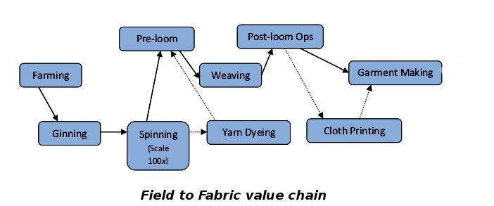
Farming: you farm it. You grow the Cotton Plant.

Ginning: you separate fibers from the seeds.

Spinning: you spin the fibers into yarn.

Weaving: you weave the yarn into cloth.

Printing: you put the image on the cloth you want.

Rewrite
1. The Industrial Revolution starts in England.
2. The Industrial Revolution starts with the textiles industry.
3. Textile industry refers to T-Shirt from Cotton.

Complete
1. How many steps are there to making textiles? 3
Spain is super rich in the 1700s. They control the textile industry. They make the best cloth. But they love mercantilism. They want to keep as much money in Spain as possible. They don’t care about production; they care about saving money. So, they make big taxes.

England takes advantage. They make some textile factories in England. They want to compete!

So, they invent a really fast way to make yarn from cotton fibers. It’s called the Spinning Jenny. It uses water wheels.

Rewrite
1. Spain is the richest country in the world in the 1700s.
2. Spain’s mistake is that they focus on Mercantilism.
3. The new invention that changes textile production in England is called the Spinning engine.

The Spinning Jenny works on water power. Water wheels spin a wheel—called a turbine—faster and faster to create power.
(Actually, all power is based on this principle, including nuclear power plants.)
The water wheel powers the factory.
Now, England is making more yarn, faster.

Summarize How does the Spinning Jenny work? It works on water power. Water wheels spin a wheel—called a turbine—faster and faster to create power.
YARN TURBINE WATER WHEEL

In America, there are two new inventions that make a better, faster T-shirt.

Eli Whitney invents the Cotton Gin. This invention makes it easier to separate seeds from fiber. The effect of this is to increase slavery, because now cotton is super profitable.

Robert Fulton invents the Steam Engine. It’s like a water wheel, but it uses vaporized water, called steam. This generates even more power: Steam Power.

Rewrite
1. Eli Whitney invents the Cotton Gin.
2. Robert Fulton invents the Steam Engine.
3. The Steam Engine uses steam to generate power.
4. The Cotton Gin increase slavery

Steam Power makes even faster Textile Factories. It also allows these new ships called steam boats and also railroads.

It becomes easier to make textiles and faster to transport them. But what do you need for steam power? Coal. Where is the coal? Under the ground. You need a strong metal to dig under the ground.

Complete
- What do they use to power the steam engines and railroads? They use the Steam Power.

You need coal to power the steam boats and Textile Factories. But to get it, you need strong tools. Steel is the strongest metal. They have steel; but it comes from iron and is expensive to make. A guy in England named James Bessemer comes up with a new way to process steel from iron. This is called the Bessemer Process.

Complete
1. What does James Bessemer invent? Bessemer process
2. Which is stronger--iron or steel? Steel is the strongest

Now, you have cheap steel, steam power, faster textile factories, railroads, and steam ships. Do you know where this is going? I think you do…

Coal Power = Yeah, it’s good for Textile Factories.

But it also powers steam ships and railroads.
Transportation is improved like never before!

Steel = Yeah, it’s good for extracting coal.

But it makes great weapons like machine guns. It also makes powerful gunships. And great big buildings!

The Europeans have steel, steam, factories, and railroads…. What do you think they are going to do? I think they are going to trade.

These are all things that make imperialism possible!
Africa and Asia are filled with natural resources to make new products. Industrialization and imperialism go hand-in-hand.

So, England starts with capitalism: making a better T-Shirt.
They invent or borrow the tools for industrialization along the way. Then, they have the tools to conquer the world and build an empire.

So, white people “invent” the game of capitalism. But it’s not over. It’s still going on… Let’s jump to 2014.

